**Question 01**

**Code**

#include<stdio.h>

#include<stdlib.h>

int main(void){

int numofelements=0,i=0,sum=0;

printf("Enter the number of elements of the array:\n");

scanf("%d",&numofelements);

int *ptr=(int*)malloc(numofelements*sizeof(int));

if (ptr == NULL){

printf("\nMemory allocation failed\n");

}

else{

printf("Enter the elements of the array:\n");

for (i=0; i<numofelements; i++){

scanf("%d",ptr+i);

sum=sum+*(ptr+i);

}

printf("\n\nThe sum of the elements is %d",sum);

free(ptr);

}

}

**Output**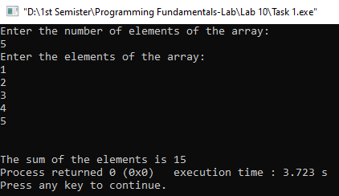

**Question 02**

**Code**

#include<stdio.h>

#include<stdlib.h>

int main(void){

int rows=0,columns=0,i=0,j=0,sum=0;

printf("Enter the number of rows:\n");

scanf("%d",&rows);

printf("Enter the number of columns:\n");

scanf("%d",&columns);

int **array=(int **)malloc(rows*sizeof(int));

for (i=0; i<rows; i++){

array[i]=(int *)malloc(columns*sizeof(int));

}

printf("Now enter the elements of the array:\n");

for (i=0; i<rows; i++){

for (j=0; j<columns; j++){

scanf("%d",(*(array+i)+j));

}

}

printf("\n\n");

for (i=0; i<rows; i++){

sum=0;

for (j=0; j<columns; j++){

sum=sum+*(*(array+i)+j);

}

printf("The sum of %d row is %d\n",i+1,sum);

}

printf("\n\n");

for (i=0; i<columns; i++){

sum=0;

for (j=0; j<rows; j++){

sum=sum+*(*(array+j)+i);

}

printf("The sum of %d column is %d\n",i+1,sum);

}

for (i=0; i<rows; i++) {

free(array[i]);

}

free(array);

}

**Output**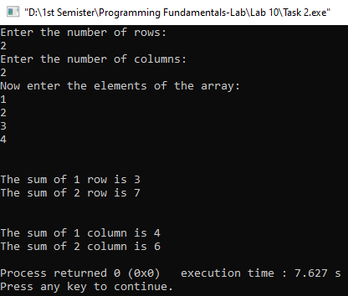

**Question 03**

**Code**

#include<stdio.h>

#include<stdlib.h>

#include<string.h>

int main(void){

char sentence[1000];

printf("Enter a sentence less than 1000 letters:\n");

gets(sentence);

char **final_array=0;

int i=0,words=0;

int count=0;

int number_of_words=strlen(sentence);

printf("\nThe length of the input character array is: %d\n",number_of_words);

for (i=0; sentence[i]!='\0'; i++){

if (sentence[i]!=' '){

count++;

}

}

printf("\nWith out space the length of the input character array is: %d\n",count);

char *token=strtok(sentence," ");

while(token!=0){

final_array = (char **)realloc(final_array,(words+1)*sizeof(char *));

final_array[words]=(char *)malloc((strlen(token)+ 1)*sizeof(char));

strcpy(final_array[words], token);

words++;

token=strtok(0," ");

}

printf("\n2D Array Output:\n");

for (i=0; i<words; i++){

printf("%s\n",*(final_array + i));

}

for (i=0; i<words; i++){

free(*(final_array+i));

}

free(final_array);

}

**Output**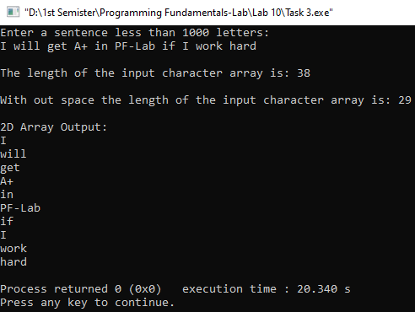

**Question 04**

**Code**

#include<stdio.h>

#include<conio.h>

#include<stdlib.h>

int main(void){

int rows=0,columns=0,i=0,j=0;

char choice;

while(choice!='N'){

printf("Enter the number of rows:\n");

scanf("%d",&rows);

printf("Enter the number of columns:\n");

scanf("%d",&columns);

int **array=(int **)malloc(rows*sizeof(int *));

for(i=0; i<rows; i++){

array[i]=(int *)malloc(columns*sizeof(int));

}

for(i=0; i<rows; i++){

for(j=0; j<columns; j++){

*(*array+i * columns+j)=rand()%401-200;

}

}

for (i=0; i<rows; i++){

int minimum=*(*array+i * columns);

int maximum=*(*array+i * columns);

for (j=1; j<columns; j++){

if(*(*array+i * columns+j)<minimum){

minimum=*(*array+i * columns+j);

} else if(*(*array+i * columns+j)>maximum){

maximum=*(*array+i * columns+j);

}

}

for (j=0; j<columns; j++) {

if(*(*array+i * columns+j)>0){

*(*array+i * columns+j)=minimum;

} else if(*(*array+i * columns+j)<0){

*(*array+i * columns+j)=maximum;

}

}

}

printf("Modified Array is:\n");

for(i=0; i<rows; i++) {

for(j=0; j<columns; j++) {

printf("%d\t",*(*(array+i)+j));

}

printf("\n");

}

for (i=0; i<rows; i++) {

free(*(array+i));

}

free(array);

printf("Do you want to continue? Y=Yes\tN=No:\n");

choice=getche();

printf("\n");

}

}

**Output**